AMANDA LOOMES

**FORMATION LEVEL**

**18 JANUARY - 24 MARCH 2019**

**PREVIEW:** Thursday 17 January, 18.00hrs

horizontal line

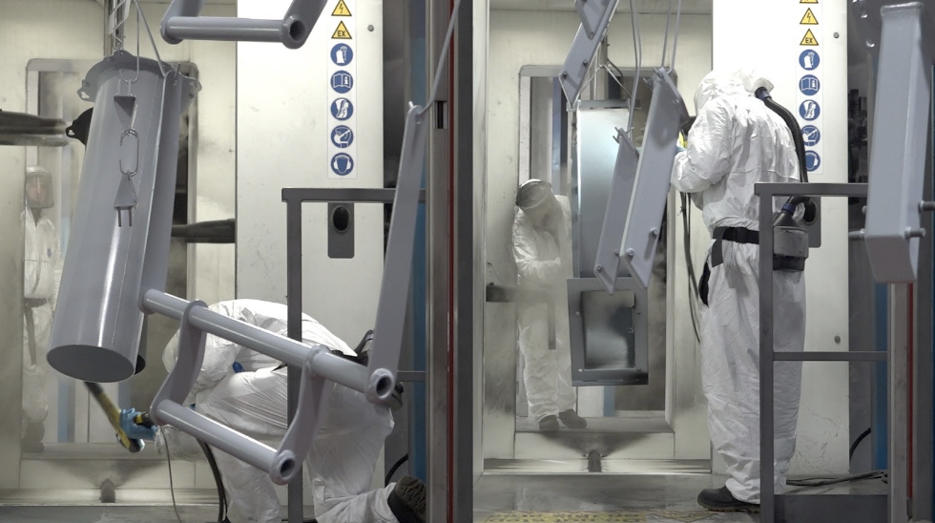

Still from *Time and Motion*, Amanda Loomes (2018/19)

**Aspex is delighted to present *Formation Level*, an exhibition of new and recent films by Amanda Loomes.**

A former civil engineer, artist/film-maker Amanda brings her technical expertise to an exploration of the materials, companies and individuals that make and maintain the roads we all use.

In the exhibition *Formation Level* Amanda uses experimental documentary techniques to record the processes and hidden narratives of the labour and materials embedded in our roads, including the manufacture of road sweepers.

The artist said:

“*People at work have always preoccupied me. I am particularly moved by work that is repeated or undone and the effort of people whose work goes unnoticed. In my practice I am drawn to record their labour as I try to capture the frailty and resilience of human endeavour*”.

The exhibition will also comprise material from Amanda’s own archive of her time as a civil engineer, including photographs, diagrams and other ephemera.

The artist completed an MA in Fine Art Painting at the Royal College of Art (2006), and BA Fine Art Painting at University of the Arts, London (2004). She has exhibited widely, including *Oriel Davies Open* (2018), *Supporting Material*, UCA Canterbury (2017), *Jerwood Open Forest*, Jerwood Space (2014) and has undertaken permanent commissions with Metal, Southend (2017), and Trust New Art, National Trust Lyme (2016). She has been a member of The London Group of artists since (2008). She has previously exhibited at **Aspex** as part of *EMERGENCY* (2011) and *South Central* (2014). The exhibition also features *Relict Material* a film installation co-commissioned by Photoworks and HOUSE in 2015 and her recent film *Whole* made in the sand quarries of the Surrey Hills, commissioned as part of *Surrey Unearthed* (2018).

Director of **Aspex**, Joanne Bushnell said:

“We first started working with Amanda on the development of this show when she won our *South Central* award in 2014. We have valued the opportunity to work closely with her for many years, supporting her ongoing professional development. It’s been great to see other opportunities such as the Photoworks/HOUSE commission come her way, and to see her practice grow from strength to strength.”

**Aspex** will be also hosting a seminar with the artist on Saturday 2 March, 14.00hrs. Gareth Bell-Jones, Curator and Director of Flat Time House and Dr Erika Balsom, Senior Lecturer in Film Studies at Kings College London will be joining the panel.

*Formation Level* is on show at **Aspex** until 24 March 2019, with a Preview on Thursday 17 January, 18.00hrs.

**Ends**

For further information please contact Oliver Tubb, Marketing & Communications Manager: [ollie@aspex.org.uk](mailto:ollie@aspex.org.uk) / 023 9277 8080

**Notes**

**Aspex**

Aspex has a 38-year track record of supporting emerging artists and engaging audiences, through the delivery of a programme of exhibitions, off-site projects and participatory opportunities. Artists such as Mona Hatoum, Richard Wilson and Susan Collis, all internationally acclaimed, received support from Aspex at an early point in their careers. This work has continued with projects including *EMERGENCY*, an open submission biennial exhibition, offering key opportunities for artist exposure and professional development.

Since relocating to the waterfront at Gunwharf Quays in Portsmouth in 2006, the gallery has focused on finding ways to meaningfully engage its visitors by facilitating connections with artists and revealing the creative process. The participation programme provides activities for toddlers through to pensioners, and its work with children with Special Educational Needs and Autism has been described as exemplary.

**W:** aspex.org.uk - **T:** @aspexportsmouth - **I:** @aspexportsmouth - **FB:** @aspexgallery

|  |  |  |
| --- | --- | --- |
|  |  |  |